Blood Glucose (mg/dL) | 0600  (Units Regular Insulin) | 1200  (Units Regular Insulin) | 1800  (Units Regular Insulin) | 2400  (Units Regular Insulin)
<70 | Treat the low blood sugar. Recheck blood glucose in 15 mins. If sugar is more than 70, then take the number of units of insulin in the 70-90 row, if before a meal.
70-90 | 1 | 2 | 3 | 3
91-130  (Base Dose) | 3 | 4 | 5 | 6
131-150 | 4 | 5 | 6 | 7
151-200 | 5 | 6 | 7 | 8
201-250 | 6 | 7 | 8 | 9
251-300 | 7 | 8 | 9 | 10
301-350 | 8 | 9 | 10 | 11
351-400 | 9 | 10 | 11 | 12
401-450 | 10 | 11 | 12 | 13
>450 | 11 | 12 | 13 | 14
Lantus insulin 22 units subcutaneous Nightly

Provider Signature: _____________________________ID No:_____________________
Date: July 29, 2026___________________Time: 00:06______________________
RN Signature: __________________________________ Date/Time: _____________

Froedtert Hospital
9200 West Wisconsin Avenue
PO Box 26099
Milwaukee, WI 53226

Primary Affiliate of the
Medical College of Wisconsin

Version 5/30/06, Owner: Endocrine
Copy 1-3 Patient
Copy 4 – Chart
Copy 5 – Nursing
Copy 6 -- Pharmacy

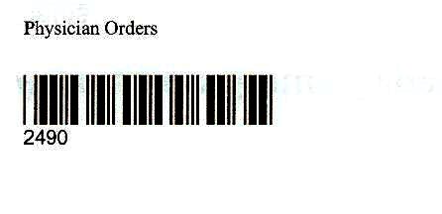

Physician Order Sheet

